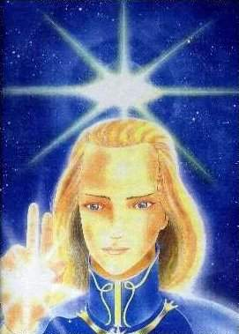
ASHTAR SHERAN – spiritual being of higher consciousness. Commander of a cosmic squadron. www.universe-people.com

