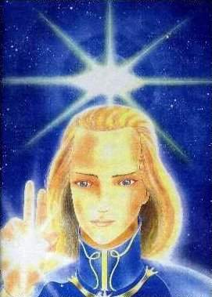

ASHTAR SHERAN

ASHTAR SHERAN

ASHTAR SHERAN

ASHTAR SHERAN

ASHTAR SHERAN

ASHTAR SHERAN

ASHTAR SHERAN

ASHTAR SHERAN

ASHTAR SHERAN

ASHTAR SHERAN

ASHTAR SHERAN

ASHTAR SHERAN

