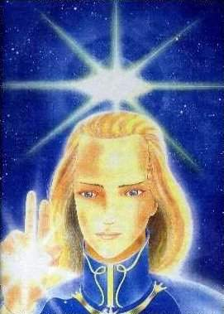

ASHTAR SHERAN

ASHTAR SHERAN

ASHTAR SHERAN

ASHTAR SHERAN

ASHTAR SHERAN

ASHTAR SHERAN

ASHTAR SHERAN

ASHTAR SHERAN

ASHTAR SHERAN

ASHTAR SHERAN

ASHTAR SHERAN

ASHTAR SHERAN

ASHTAR SHERAN

ASHTAR SHERAN

ASHTAR SHERAN

ASHTAR SHERAN

